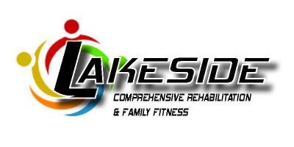
BLACK FRIDAY SALES
Small Business Saturday
Nov. 26, 2016
November 25, 2016
Discounts on:
- EXCEL All Facility & Standard Gym Memberships
- Enrollment Fees Waived
Second Chance Saturday Sales
Dec. 3, 2016
- Massage Packages of 6 starting at $115
- Martial Arts Packages starting at $99
- Personal Training Packages of 6 starting at $142
- Tumbling Discounts
- Swim Lesson Discounts
- Pay in Full Discounts
- Purchase 3 Months Membership & Receive 20% off

Purchase at either location:
39 State St. Hart, MI 49420: 5am- End of Holiday Parade
601 E Main Street: 5am – 6 pm
Phone Orders taken by calling: 231-873-3577 8am -12 pm

Join us for refreshments before and after the holiday parade at our downtown location 39 State Street Hart, MI. We look forward to helping fill your stockings with a Gift of Love and Wellness this Holiday Season.
*Look for the ad in the Freeway for an extra special coupon* www.lakesiderehab.com

